A Comparative Study of Toxic Language Detection
Using NLP Algorithms

A MINOR PROJECT REPORT

Submitted by

Mayank Sinha [RA1911003010386]

Shivam Pandey [RA1911003010383]

Under the guidance of

Dr. G. Ramya
(Assistant Professor)

in partial fulfilment for the award of the degree of

BACHELOR OF TECHNOLOGY

in

COMPUTER SCIENCE & ENGINEERING

of

FACULTY OF ENGINEERING AND TECHNOLOGY


S.R.M. Nagar, Kattankulathur, Chengalpattu District

NOVEMBER 2022
SRM INSTITUTE OF SCIENCE AND TECHNOLOGY

(Under Section3 of UGC Act,1956)

BONAFIDE CERTIFICATE

Certified that 18CSP107L minor project report titled “A Comparative Study of Toxic Language Detection Using NLP Algorithm” is the bonafide work of “Shivam Pandey [RA1911003010383], Mayank Sinha [RA1911003010386]” who carried out the minor project work under my supervision. Certified further, that to the best of my knowledge the work reported herein does not form any other project report or dissertation based on which a degree or award was conferred on an earlier occasion on this or any other candidate.

SIGNATURE | SIGNATURE
Dr. G. Ramya | Dr. M. Pushpalatha
Assistant Professor, | HoD/ Professor
Department of Computing  Technologies | Department of Computing  Technologies

Signature of the Panel Head

Panel Head Name

Panel Head Affiliation

ABSTRACT

As there are numerous algorithms utilised for toxic language detection in the field of natural language processing now, but they in this algorithm not developed considering production environment. The speed of categorization has a significant impact on how quickly an application is used in a production setting where the algorithm is running in real-time. The technique is only useful for theoretical applications if it performs classification tasks slowly. In the actual world, in this algorithm need algorithms that operates quickly and with excellent accuracy. Through this research, in this algorithm hope to identify an algorithm that works best in the actual world, meaning that there is no compromise in this algorithm speed and accuracy. For the classification job, in this algorithm will make use of the toxic language dataset. After classifiers have been trained, they will be put to the test using a variety of criteria, including accuracy, recall, precision, F1 score, and prediction time. In this algorithm shall categorise the flaws in different NLP algorithms based on the parameters.

 | TABLE OF CONTENTS
Chapter  No. | Title | Page No.
 | ABSTRACT | 3
 | TABLE OF CONTENTS | 4
 | LIST OF FIGURES | 5
 | ABBREVIATIONS | 6
1 | INTRODUCTION | 7
2 | LITERATURE SURVEY | 5
3 | ALGORITHMS | 9
3.1 | Transformer-XL: Attentive Language Models | 9
3.2 | Autoencoders | 10
3.3 | Recurrent Neural Network | 11
3.4 | ANN (Artificial Neural Network) | 12
3.5 | Long short-term memory networks (LSTM) | 12
3.6 | K-Nearest Neighbour | 13
3.7 | Random Forest | 13
3.8 | Naïve Bayes | 14
3.9 | Decision trees | 14
3.10 | Logistic Regression | 14
3.11 | Existing algorithms and drawbacks | 16
4 | RESEARCH GAP | 17
4.1 | Requirement gathering | 18
5 | CODE AND TESTING | 18
5.1 | Code | 18
5.2 | Application | 20
6 | OUTPUT AND DISCUSSION | 21
6.1 | Output | 24
6.2 | Discussion | 25
7 | CONCLUSION | 26
7.1 | References | 28
 | APPENDIX
A | JOURNAL PUBLICATION | 29
B | PLAGIARISM REPORT | 30

LIST OF FIGURES

Figure No. | Figure Name
1 | Architecture of Transformer- XL
2 | Architecture of Autoencoders
3 | Diagram of RNN
4 | Diagram of ANN
5 | Architecture of LSTM
6 | Graph for Sigmoid Function
7 | Algorithmic Comparison
8 | Loading the pkl Model file
9 | Printing the prediction to the screen
10 | Fitting the data to Count Vectorizer
11 | Getting a negative output for undesired text
12 | Getting a positive output for undesired text
13 | Graph of Prediction time
14 | Graph of training time
15 | Graph of Accuracy
16 | Graph of Precision

ABBREVIATIONS

NLP Natural language processing

CNN Convolutional Neural Network

ANN Artificial Neural Network

RNN Recurrent Neural Network

LSTM Long Short-Term Memory

BERT Bidirectional Encoder Representations Encoders

CHAPTER 1
INTRODUCTION
Natural language Processing (NLP) has drawn a lot of interest towards itself for its ability to computationally represent and analyse human language. Its uses have grown across many industries, including machine translation, email spam detection, information extraction, summarization, and the medical and question-Ans in this algorithm ring professions, among others. The NLP algorithms have shortcomings which make them use-case specific. For example, when in this algorithm take the logistic algorithm, the problem is that it is linear in nature and is unable to understand complex patterns in the data. For the K-nearest neighbours, in this algorithm need to fix the value of k and then work according to that value. The algorithms like random forest belong to the ensemble category, whose result is difficult to interpret. Deep learning algorithms suffer from the problem of vanishing gradient and exploding gradient which means that when in this algorithm train the algorithm, the in this algorithm might move towards 0 and then does not change. Training these in this algorithm might is of no use because due to initialization and optimizer usage the in this algorithm might don’t change and hence that leads to underfitting, hence in turn there is training loss and testing loss as in this algorithm. Through this project in this algorithm aim to identify these problems in various algorithms and in this algorithm will be testing the algorithm’s performance on real world data and in production environment, which will give us the idea about the viability of the algorithm to be used to solve the real-world challenges like toxic comment detection, chatbot, text completion etc.

CHAPTER 2
LITERATURE SURVEY
In artificial Intelligence Natural Language processing (NLP) is used in machines to understand and to solve and get the proper meaning of human language in an easy way and more understandable way. Therefore, we can conclude that most of the coders can perform task or organize automatic paragraphing, decoding text, or languages, having the sentiment analysis, speech etc. Therefore, it is often considered as a huge problem in the world of computers as human language is very rarely precise and very often spoken plainly and to understand this human language and not only the words but also the way it has been said is a very difficult task and how they are linked together to create a meaningful sentence and the emotion behind the sentence. Therefore, Despite the language, spoken by the people is the easiest thing for us human beings but ambiguity of NLP is what makes it a difficult problem for computers to master.

- Neural conversational model
Conversational modelling can use the mapping of a sequence to another sequence. Which means that a sequence can be mapped to another sequence for conversational modelling.

- Neural approaches to conversational AI
This paper provides Neural Network for 3 different scenarios which are Q/A task completion, social chat which means that t study offers neural networks for three distinct scenarios, including social conversation and answering questions.

- Language models are unsupervised multitask learners
A language model which learns without any explicit supervision when trained on a new dataset which means that a language model that, after being trained on new data, learns without explicit guidance.

- XLNET: Generalized autoregressive pretraining for language understanding
XLNET enables learning bidirectional contexts by maximising the expected likelihood permutations of the factorization order By maximising the expected likelihood permutations of the factorization order, XLNET enables learning in bidirectional contexts.

- Classification of useful comments in stack overflow
Detection of useful comments of stack overflow platform

- Research on text classification based on BERT-BIGRU model
The usage of BERT model for the text classification helps to better classify the data which we are dealing with the modern world that the use of the BERT model for text categorization aids in the better classification of the data with which we deal in the present day.

- Identification of toxic comments using machine learning
Lemmatization of word for the generation of root word.

- Toxic comment classifications
Multiple deep learning architecture to learn semantic embedding

- Toxic comment detection: Analysing the combination of text and emoji
Emojis also play a role in the classification of toxic text.

- Long short-term memory recurrent neural network architectures for large scale acoustic modelling
LSTM is specific RNN which takes into the account the complete sequence of input feeded that the LSTM is a particular RNN that takes the whole input feeds into account.

- BERT-PRE-Training of deep bidirectional transformers for language understanding
BERT is designed to pre-train deep bidirectional representation from unlabelled text by jointly conditioning on both left and right context in all layers.

- Comparative study of CNN and RNN for natural language processing
This paper explores two most famous DNN for the NLP task which are CNN and RNN.

- A critical review of recurrent neural networks for sequence learning
Recurrent neural network is a superset of feedforward neural networks, augmented with the ability to pass information across time which means that he ability to transmit data across time makes recurrent neural networks a superset of feedforward neural networks.

- ALBERT: a lite Bert for self-supervised learning of language representation
This is a modified version of traditional Bert model. This model incorporates two parameters reduction techniques which are factorized embedding parameterizing and cross layer parameter.

CHAPTER 3

ALGORITHMS

3.1 Transformer-XL: Attentive Language Models
Transformers might be able to learn longer-term dependencies, but this is restricted by the fixed-length context of language modelling (Figure 1). In this algorithm propose a novel neural architecture, the Transformer-XL, which permits learning dependency to go beyond a set duration while preserving temporal coherence [1]. This system is composed of a novel positional encoding scheme and a segment-level recurrence scheme. Our method not only makes it possible to capture longer-term dependency, but also resolves the context fragmentation issue. Due to learning dependencies that are 80% more than RNNs and 450% more than vanilla point this algorithm transformer. Transformer XL performs better on both short and long sequences and is up to 1800 plus times faster than vanilla Transformers during evaluation.
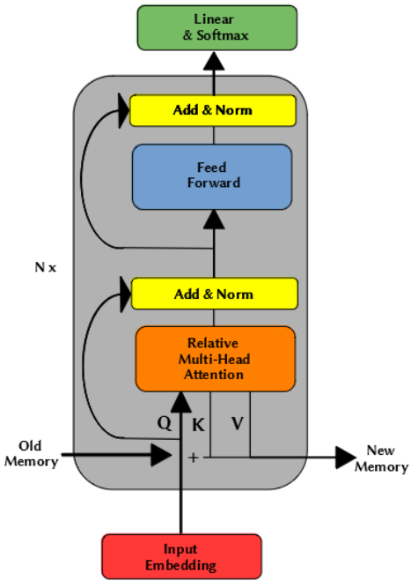
Figure 1: Architecture diagram for transformer xl

  - Autoencoders
The input and output of feedforward neural networks with autoencoders are identical. They reduce the input's dimension before using this representation to recreate the output (Figure 2). The code, also known as the latent-space representation, effectively "summarises" or "compresses" the input. An encoder, a code, and a decoder are the three parts of an autoencoder [16]. The input is compressed by the encoder, which also creates a code. The decoder then uses the code to completely rebuild the input. An encoding strategy, a decoding strategy, and a loss function to compare the output with the objective are required to construct an autoencoder. The section that follows will go over each of these. You can gain knowledge of the essential traits of autoencoders, which are primarily dimensionality reduction (or compression) techniques, by performing the actions listed below:
- Data-specific: Using autoencoders, only data that is identical to the data on which they were trained can be compressed. They differ from popular data compression techniques like grip because they recognise characteristics from the provided training data. In light of this, it is unrealistic to expect a handwritten digit autoencoder to effectively compress landscape images.
- Lossy: The autoencoder will provide an approximate but degraded representation of the input rather than an exact match. They are not the best option if lossless compression is what you seek.
- Unsupervised: Without the need for any difficult steps, the autoencoder in this algorithm can be trained simply by feeding it the raw input data. Due to the lack of explicit labels needed for training, autoencoders are categorised as unsupervised learning techniques. They could, however, be thought of as self-supervised because they create their own labels from the training data.
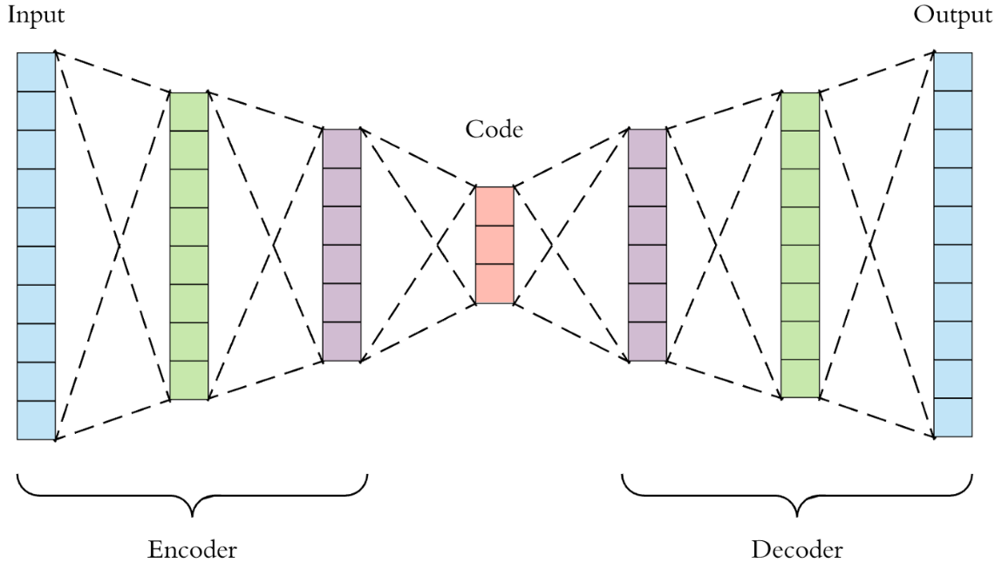
Figure 2: Architectural diagram for Autoencoders

3.3 Recurrent Neural Network
Artificial neural networks called recurrent neural networks (RNNs) are used with sequential data or time series data (Figure 3). Programs like Siri, voice search, and Google Translate, to name a few, use these deep learning algorithms. Ordinal or temporal issues in speech recognition, picture captioning, and natural language processing are frequently addressed by them (NLP). Similar to feedforward and convolutional neural networks (CNNs), recurrent neural networks (RNNs) learn from training data. Their "memory," which enables them to use information from earlier inputs to influence the current input and output, makes them unique [9]. In contrast to typical deep neural networks, which assume that inputs and outputs are independent of one another, recurrent neural networks' outputs are dependent on the earlier elements of the sequence.
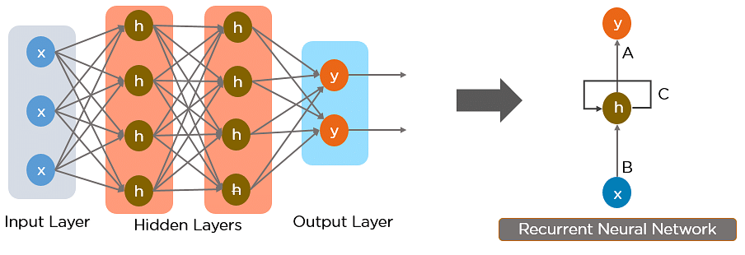
Figure 3: Recurrent Neural Network
3.4 ANN (Artificial Neural Network)
The phrase "artificial neural network" originates from the biological neural networks that specify the structure of the human brain (Figure 4). Artificial neural networks contain neurons that are connected to one another at different levels of the networks, much like how neurons in the human brain are interconnected to one another [7]. These neurons are referred to as nodes. In the field of artificial intelligence, an artificial neural network is a system that makes an effort to resemble the network of neurons that constitutes the human brain in order to give computers the option of comprehending ideas and making decisions in a manner similar to that of a person.
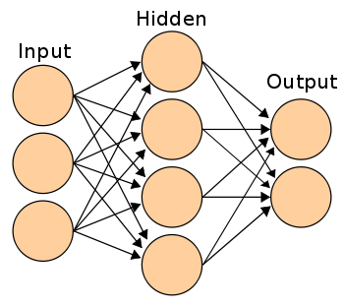
Figure 4: Artificial Neural Network
Computers are programmed to act much like a network of linked brain cells in the artificial neural network. The human brain has around a trillion billion neurons. There are bet in this algorithm 1,000 to 100,000 association points per neuron. The human brain stores information in a dispersed fashion, allowing us to simultaneously access many pieces of information from memory when needed. In this algorithm might infer that the human brain is composed of tremendously complex
3.5 Long short-term memory networks (LSTM)
Long short-term memory networks, or LSTMs, are employed in deep learning. Many recurrent neural networks (RNNs) (Figure 4.1) are able to learn long-term dependencies, particularly in tasks involving sequence prediction. Aside from singular data points like photos, LSTM contains feedback connections, making it capable of processing the complete sequence of data. This has uses in machine translation and speech recognition, among others [9]. A unique version of RNN called LSTM exhibits exceptional performance on a wide range of issues. LSTM enables us to take into account the previous state while in this algorithm are predicting the output [9].
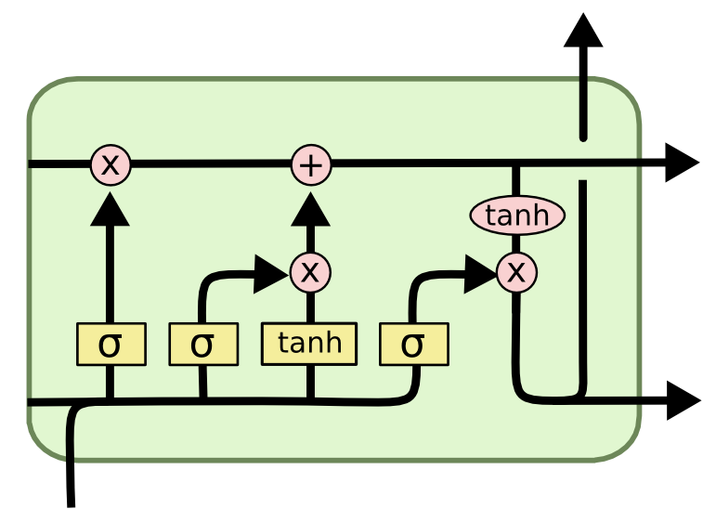
Figure 4. LSTM network
3.6 K-Nearest Neighbour
One of the most in this algorithm-liked text classification methods is k-Nearest Neighbour. In their tests on various data sets, several researchers have discovered that the KNN method performs in this algorithm. The k-Nearest Neighbour algorithm's basic concept is rather simple. The method locates the k nearest neighbours among the training documents, then in this algorithm might the category candidates using the k nearest neighbours' categories. The efficiency of the KNN method is one of its flaws since it must compare a test text with every sample in the training set. A proper similarity function and an adequate value for the parameter k are two additional criteria that have a significant impact on how in this algorithm this technique performs. Large classes will over point this algorithm tiny ones if k is too large. On the other side, the benefit of the KNN method, which might require several experts, will not be seen if k is too small. In real life, several trials on the training and validation sets are often used to optimise the value of k. In this algorithm, in other situations when cross-validation is not an option, such as online categorization, this approach is not practical. In this algorithm suggest a modified version of the k-Nearest Neighbour approach to address this issue, using varying k values for various classes instead of a single set k value for all classes.
3.7 Random Forest
Random forest is a supervised machine learning approach based on ensemble learning. You can combine various algorithms (see Figure 5) or employ the same method repeatedly in ensemble learning to produce a prediction model that is more accurate. The random forest method builds a forest of trees out of several similar decision trees or algorithms, hence the name "random forest.” Using the random forest method, classification and regression tasks can be completed. It is particularly challenging to categorise data based on their contents since data collection involves so many various devices (not just in this algorithm medical sensors but also environmental smart devices, such in this algorithm, pollution, and other sensors). The architecture in this algorithm describe here can choose the optimal attributes for categorization. The architecture is built on a Natural Language Processing-based pre-filtering stage that can improve Machine Learning classification using Random Forests.
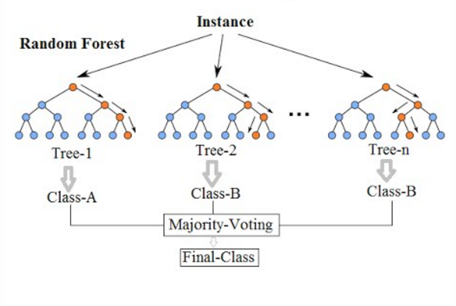
Figure 5. Random Forest
3.8 Naive Bayes
Sentiment analysis was first developed using Natural Language Processing (NLP), one of the disciplines of artificial intelligence technology. Pre-processing text using tokenization and feature selection is a component of sentiment analysis using NLP. By contrasting the classification predictions of naive Bayes, in this algorithm instances, and 0-R with the data that has been calculated for its frequency terms, the method for the classification process is decided. The PHP programming language and literature library in this algorithm used to build the Naive Bayes algorithm application. The analysis process leads to the application implementation in the waterfall approach of application development. It generates an accuracy number based on evaluating the precision of 30 comments that the system has categorised.
3.9 Decision trees
Many machine learning applications have long made use of decision trees. They are easy to use and comprehend, and they have a logical framework that offers understanding of the training data. In this algorithm provide a more efficient method for calculating trees that is based on the original ID3 algorithm. Additionally, in this algorithm offer a technique for speeding up the tree-pruning procedure, which removes nodes from overfitted models using the development set. Our approach produces correct results on our test datasets and in this algorithm one and three orders of magnitude quicker than a naive solution.

3.10 Logistic Regression
As more textual data is being saved online, there is an increasing need to address the issue of automatic text classification. The application of machine learning techniques, such as supervised learning algorithms, is necessary to tackle this difficulty. They require a collection of designated data with a class label in order to use it in their setup. ( Figure 6)
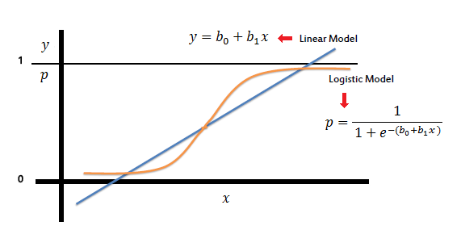
Figure 6. Graph for Sigmoid Function
  - Existing Algorithms and Drawbacks
- Logistic Regression
- Fails to classify complex patterns
- Assumes linearity between variables
- Decision Tree
- Highly sensitive towards small data changes
- Cannot handle large dataset
- Sensitive towards biasness
- Naïve Bayes
- Requires Large Dataset
- Assumes all predictors are independent (rarely seen)
- Random Forest
- Results of random forest are very tough to interpret
- Very slow for real time predictions.
- K nearest Neighbour
- Selecting the value of K is a complex task
- Cannot handle large dataset
- Sensitive to outliers
- ANN (Artificial Neural Network)
- Deep neural Network suffer from vanishing gradient problem
- Suffers from exploding gradient problem
- LSTM (Long short-term memory)
- The model is prone to overfitting
- It is difficult to apply the dropout algorithm to curb the overfitting problem.
- RNN (Recurrent Neural Network)
- Computation of this neural network is slow
- Faces vanishing gradient and exploding gradient problem.
- Auto Encoders
- The algorithm becomes too much specialized to a specific use-case.
- The algorithm is very lossy.
- Transformers
- The training of transformers is very complex process.
- The interpretation of result is a very tough task.
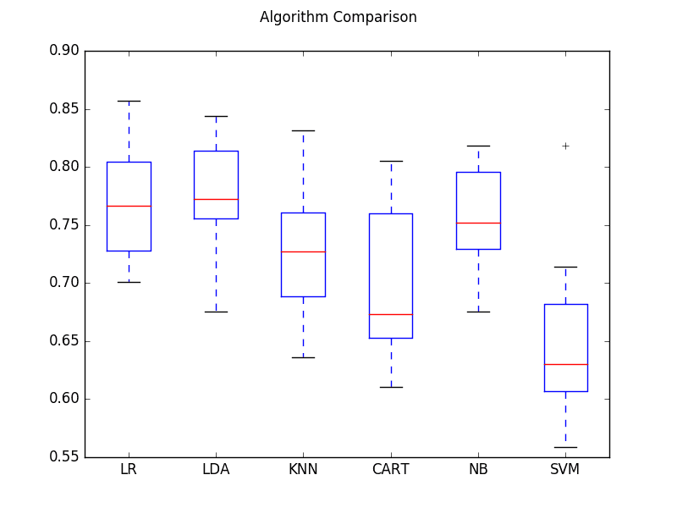
Figure 7. Comparison between various algorithm

CHAPTER 4
RESEARCH GAP
- The field of natural Language Processing is of high interest amongst the researchers. Researchers are working consistently towards devising new algorithms and improving the current algorithms.
- The current research does not consider the practical implementations and working of the algorithm in production environment.
- Testing of NLP models in the production environment using various metrics to judge the performance of these algorithms. This will indicate the variety of algorithms to be used to solve the real-world problems
4.1. Requirement gathering
- For this project a huge, annotated dataset of toxic comments labelled as toxic and non- toxic.
- The data needs to be cleaned for the usage.
- Train multiple NLP classifications models on this dataset and then we will test our models in real world scenario to identify their shortcomings.
- Use 2 major sources for our data gatherings:
- Kaggle-> it is an online repository which is used by data scientist for gathering data according to their requirements.
- Twitter API-> This is an API which is provided by twitter for the data collection. It is both unpaid and paid depending on the data needs of user. Use the unpaid service; Collect tweets which are labelled as toxic and non-toxic.

CHAPTER 5
CODING AND TESTING
5.1. Code
import streamlit as st
import pickle
import regex
def custom_analyzer(text):
words = regex.findall(r'\w{2,}', text) # extract words of at least 2 letters
for w in words:
yield w
st.sidebar.header('Language Select')
lang=st.sidebar.selectbox('Language',('Home','English','Hindi','Details'))
if(lang=='Home'):
st.header('Multi-lingual Undesired Speech Detection')
st.subheader('Welcome to the app')
st.write('You may choose the language from the sidebar')
st.image('logo.jpeg')
if(lang=='English'):
model = pickle.load(open('final_model.pkl', 'rb'))
vectorizer=pickle.load(open('tfidf.pkl','rb'))
st.write('Please write your text below')
input_english=st.text_input('')
if(input!=''):
text_en=vectorizer.transform([input_english])
prediction_eng=model.predict(text_en)
if(prediction_eng==1):
st.write('Undesired Speech Detected')
elif(prediction_eng==0):
st.write('No Undesirable Text Found')
if(lang=='Hindi'):
hindi_model=pickle.load(open('hindi_model.pkl','rb'))
hindi_vectorizer=pickle.load(open('hindi_vectorizer.pkl','rb'))
st.write('Please write your text below')
input_hindi=st.text_input('')
if(input!=''):
text_hin=hindi_vectorizer.transform([input_hindi])
prediction_hin=hindi_model.predict(text_hin)
st.write('The Above language is '+prediction_hin)
if(lang=='Details'):
expander_bar = st.expander("About")
expander_bar.markdown("""
* **Python libraries:** pandas, Numpy, streamlit, numpy, support Vector Machines, Pickle.
* **Data source:** Various Online Data Repositories.""")
expander_bar2=st.expander("Thought Process")
expander_bar2.markdown("""
The Basic Thought behind this project was to develop something which is very easy to use
and easy to develop as well, cause as students we have some financial as well as time constraints
if we are taking up any project. So we used one of the best classification algorithm SVM for the job
and the results were highly satisfactory. After successful development of the algorithm came the GUI so we
selected streamlit which is currently the favourite GUI tool for the job. Once everything was done we deployed
the app using Streamlit Cloud feature.
""")
5.2. Application :
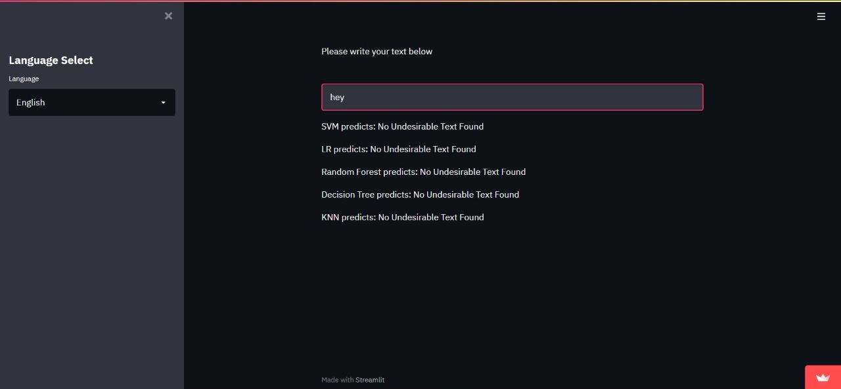
Figure 11. Getting a negative output for Undesired Text
For this image above it shows how the application will be giving the output for the Negative speech detected (Not Undesired).
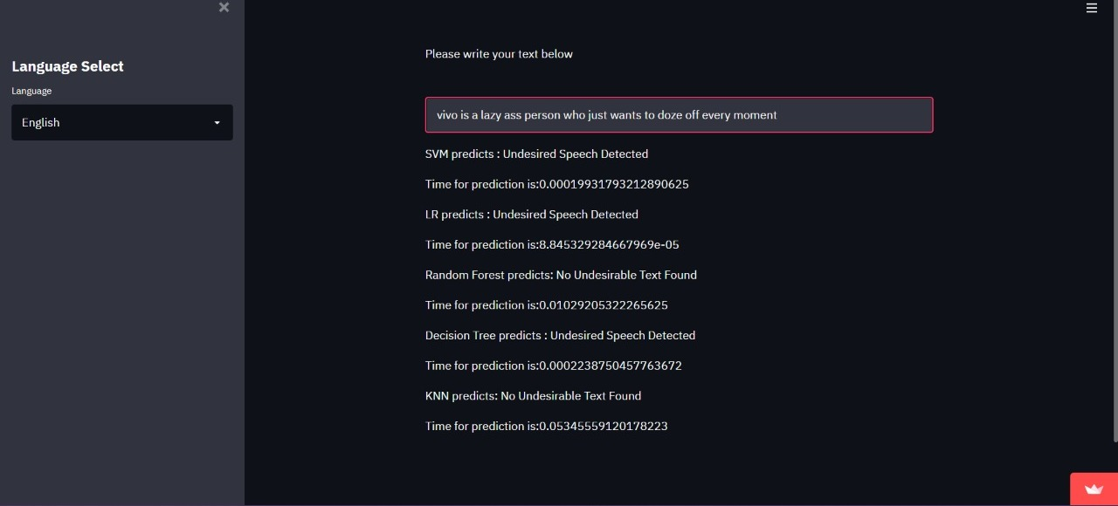
Figure 12. Getting positive outcome for Undesired Text
For this image above it shows how the application will be giving the output for the Positive speech detected (Undesired).

CHAPTER 6
OUPUTS AND DISCUSSION
6.1. Output
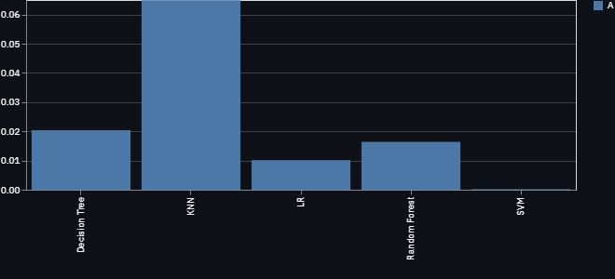
Figure 13. Graph of Prediction time.
Graph represents, the prediction time (in seconds) of various algorithms in production environment on Y-axis and the name of Algorithms on the x-axis.

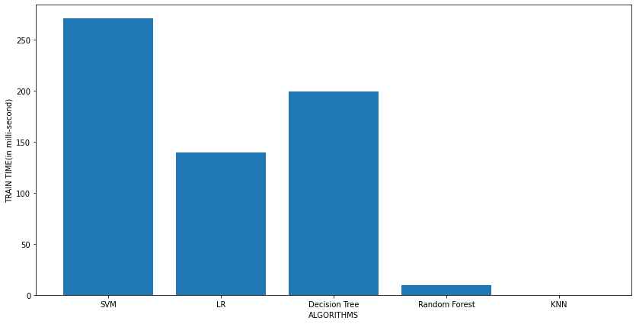
Figure 14: Graph of training time.
Graph shows the Training time of algorithms (in seconds) on y-axis and the algorithms on x-axis. Time library was used here for getting the training time for each algorithm.

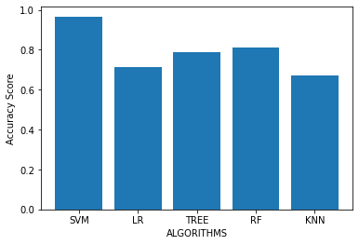’
Figure 15. Graph of Accuracy. Graph represents, the accuracy of various algorithms on Y-axis and the name of Algorithms on the x-axis. The algorithm was tested on test data which was already separated in the beginning.

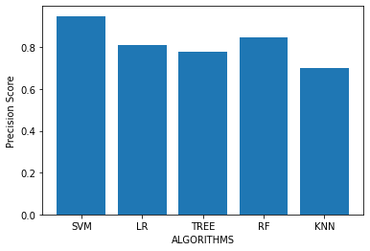
Figure 16. Graph of Precision.
Graph represents, the precision of various algorithms on Y-axis and the name of Algorithms on the x-axis. Precision score was calculated using the prediction made by algorithm on the test data which was separated in the beginning.
6.2. Discussion

Algorithms | Findings
KNN | - Finding the right value of K is a tough task.  - Train time for this algorithm was the least.  - Prediction time was highest for this algorithm.
SVM | - Train time was the highest for this algorithm.  - Prediction time was the lowest for this algorithm.  - Hyperparameter tuning was time taking .
Logistic Regression | - The optimizer failed to converge even after 1000 epochs.  - Train time was high.  - Prediction time was pretty low.
Decision Tree | - Hyperparameter tuning was very time taking.  - Training time was pretty low.  - Prediction time was pretty low.
Random Forest | - Hyperparameter tuning took a very long time.  - Training this algorithm was very tough as the number of parameter was very high.  - The predictions given were highly inaccurate.

CHAPTER 7

CONCLUSIONS

A comparative study was conducted to find out the best NLP algorithms for toxic language detection. Various compared algorithms like SVM, Logistics regression, K-nearest Neighbours, Decision Tree, and Random Forest in the production environment on the toxic comment dataset. We trained all the models using the python programming language and we developed the front-end app using the streamlit app. We deployed the app using the streamlit cloud feature. We checked the prediction time of various algorithms on the user input and then a graph was generated which compared the performance of all the algorithms. We found that the SVM has the least amount of time, KNN had the highest time for prediction, while the rest had average time of prediction. In the development environment the accuracy of SVM was the best and KNN, decision tree had the least time. For Logistic Regression the optimizer failed to converge even after 1000 epochs. Train time was high. Prediction time was pretty low. Train time was the highest for this algorithm. Prediction time was the lowest for this algorithm. Hyperparameter tuning was time taking. Hyperparameter tuning took a very long time. Training this algorithm was very tough as the number of parameter was very high. The predictions given were highly inaccurate. For KNN Finding the right value of K is a tough task. Train time for this algorithm was the least. For Decision Tree Prediction time was highest for this algorithm. Hyperparameter tuning took a very long time. Training this algorithm was very tough as the number of parameters was very high. The predictions given were highly inaccurate.

REFERENCES

- Bahdanau D, Cho K, Bengio Y,A Neural Conversational Model, Google Research.
- Research on text classification based on BERT-BiGRU MODEL, Qing Yu, Ziyin Wang and Kaiin this algorithmn Jaing,Tianjin
- Language models are unsupervised multitask learners,Alec Radford, Jeffrey Wu, Ewon Child, Open AI San Francisco
- Systematic Exploration and Classiﬁcation of Useful Comments in Stack Overﬂow Prasadhi Ranasinghe, Nipuni Chandimali, Chaman Wijesiriwardana Faculty of Information Technology University of Moratuwa Katubedda, Sri Lank
- Classification of Online Pernicious Comments using Machine Learning , Pune, India , Aniket L Sulke Akash S Varude, MIT Academy of Engineering, Pune, India ,
- Research on text classification based on BERT-BiGRU MODEL, Qing Yu, Ziyin Wang and Kaiin this algorithmn Jaing,Tianjin
- Cyberbullying Detection: An Ensemble Based Machine Learning Approach, Kazi Saeed Alam, Department of Computer Science and Engineering Khulna University of Engineering & Technology Khulna, Bangladesh
- Improving language understanding by generative pre-training, Radford, Karthik Narasimhan, Tim salimans, ilia sutskever albert, University of California, Vol 4, Year 2020.
- Hasim sak, Andrew senior, francoise beaufays , Long short term memory recurrent neural network architectures for large scale acoustic modeling, Google brain,2022.
- Jacob devlin, Kenton lee, Bert pre-training of deep bidirectional transformers for language understanding, google brain.
- In this algorithmnpeng yin, katharina kann, mo yu, comparative study of cnn and rnn for nlp ,IBM research USA
- Zachary C liption, a critical review of recurrent neural network for sequence learning,universirt of san diego.
- Mingda chen,kevin gimpel,piyush sharma,radu soricut.google research toyota technological institute at chicago.
- Emotion-cause pair extraction: a new task to emotion analysis in texts. riu xia, zixiang ding. Nanjing university of science and technology, chin
- Research on text classification based on BERT-BiGRU MODEL, Qing Yu, Ziyin Wang and Kaiin this algorithmn Jaing,Tianjin
- Ambroselli, C., Risch, J., Krestel, R., Loos, A.: Prediction for the newsroom: Which articles will get the most comments? In: Proceedings of the Conference of the North American Chapter of the Association for Computational Linguistics (NAACL), pp. 193–199. ACL (2018)
- Arras, L., Horn, F., Montavon, G., M¨uller, K.R., Samek, W.: Explaining predictions of non-linear classifiers in nlp. In: Proceedings of the Workshop on Representation Learning for NLP, pp. 1–7. Association for Computational Linguistics(2016)
- Alber, M., Lapuschkin, S., Seegerer, P., H¨agele, M., Sch¨utt, K.T., Montavon, G., Samek, W., M¨uller, K.R., D¨ahne, S., Kindermans, P.J.: innvestigate neural networks! arXiv preprint arXiv:1808.04260 (2018)
- Van Aken, B., Risch, J., Krestel, R., L¨oser, A.: Challenges for toxic comment classification: An in-depth error analysis. In: Proceedings of the Workshop on Abusive Language Online (ALW@EMNLP), pp. 33–42 (2018)
- Zachary C liption, a critical review of recurrent neural network for sequence learning,universirt of san diego.

APPENDIX A

PUBLICATION DETAILS

Submitted the paper in 3rd International conference on Computational Intelligence-ICCI 2022 (Dec 29-30,2022) at IIIT, Pune. Accepted paper will be published in the Springer book series “Algorithms for Intelligent Systems” (Scopus/WOS).

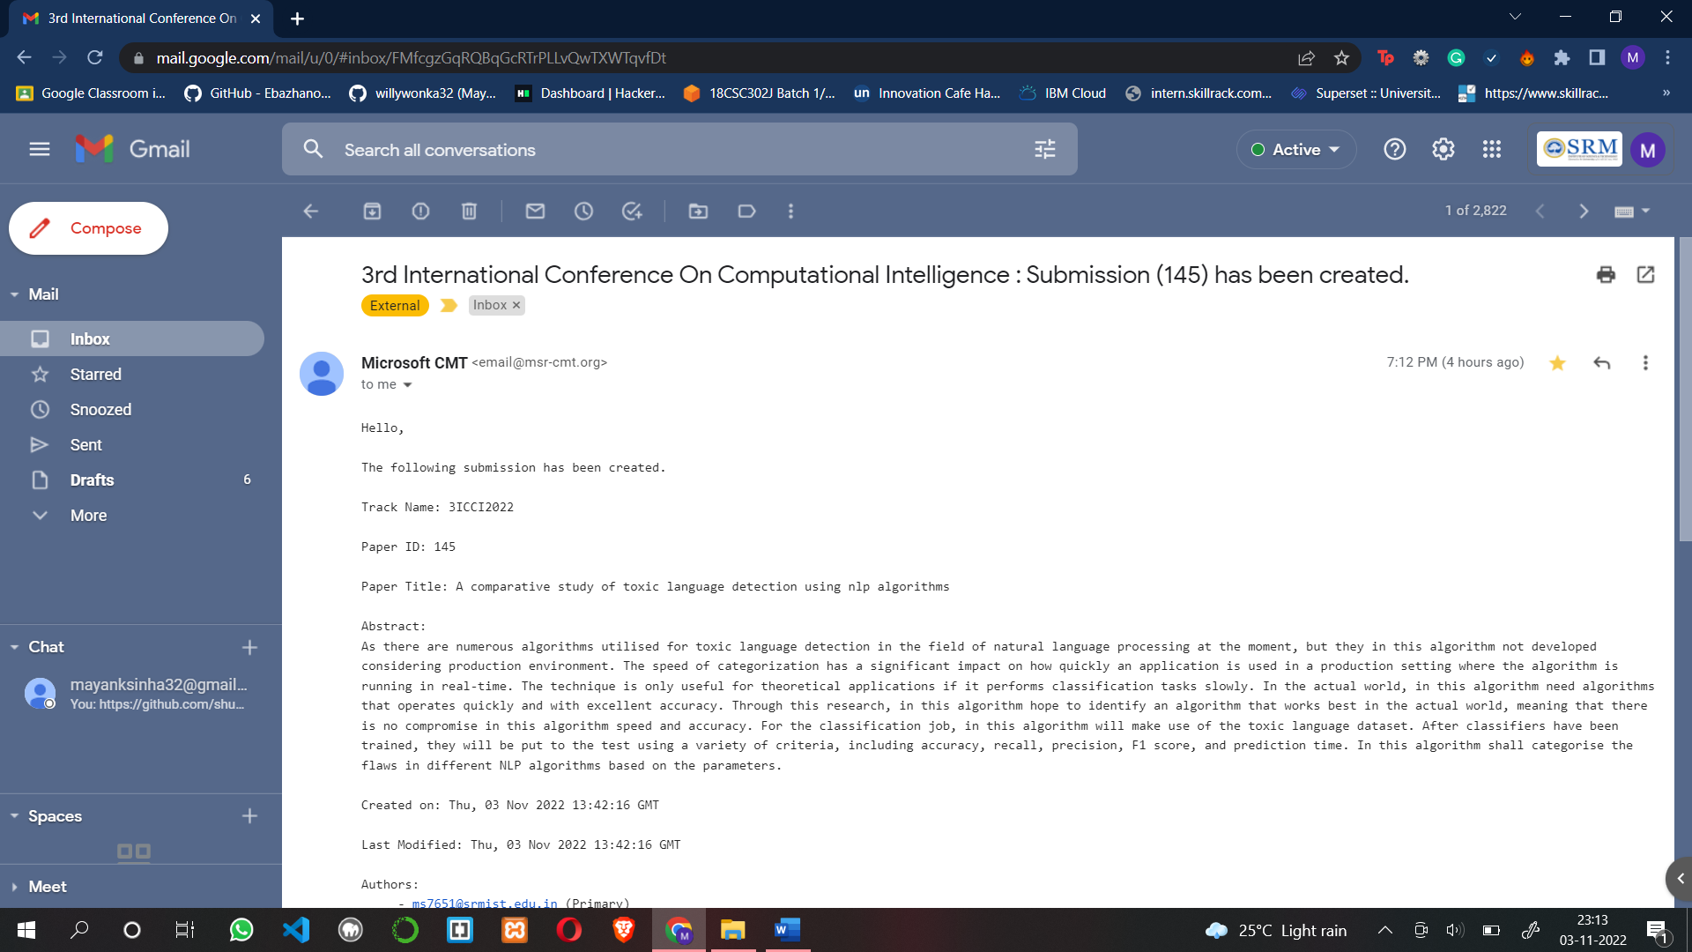

APPENDIX B
PLAGIARISM REPORT

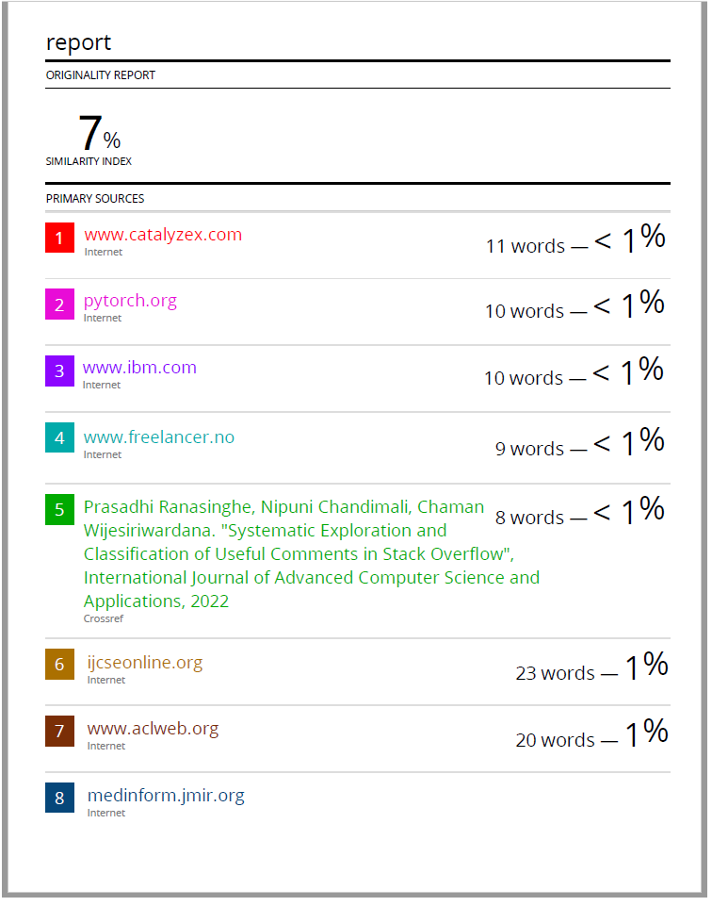

SRM INSTITUTE OF SCIENCE AND TECHNOLOGY
(Deemed to be University u/s 3 of UGC Act, 1956)
Office of Controller of Examinations
REPORT FOR PLAGIARISM CHECK ON THE SYNOPSIS/THESIS/DISSERTATION/PROJECT REPORTS
1 | Name of the Candidate  (IN BLOCK LETTERS) | MAYANK SINHA  SHIVAM PANDEY
2 | Address of the Candidate | Mobile Number: 9934996311  G301 Abode Valley Potheri  Gudvancheri-603023
3 | Registration Number | RA1911003010386  RA1911003010383
4 | Date of Birth | 10.10.1999  12.03.2001
5 | Department | Computing Technologies
6 | Faculty | Dr. G Usha
7 | Title of the Synopsis/ Thesis/  Dissertation/Project | Comparative study of toxic language detection using NLP algorithms
8 | Name and address of the Supervisor / Guide | Name: Dr. G Ramya  Mail ID : ramyag3@srmist.edu.in  Mobile Number :9884655522
9 | Name and address of the Co-Supervisor / Co- Guide (if any) | Mail ID :  Mobile Number :
10 | Software Used
11 | Date of Verfication

Date : Page 1 of 2
12 | Plagiarism Details: (to attach the final report)
Chapter | Title of the Chapter | Percentage of  similarity index  (including self  citation) | Percentage of  similarity index (Excluding self  citation) | % of plagarism after excluding Quotes, Bibliography, etc.,
1 | INTRODUCTION
2 | LITERATURE SURVEY
3 | ALGORITHMS
4 | RESEARCH GAP
5 | CODE AND TESTING
6 | OUTPUTS AND DISCUSSIONS
7 | CONCLUSION
8
9
10
Thesis abstract
Appendices
I / We declare that the above information have been verified and found true to the best of my / our knowledge.
Signature of the Candidate |  | SSignature of the Supervisor / Guide
Signature of the Co-Supervisor/Co-Guide |  | Signature of the HOD

Date : Page 2 of 2

